

SUICIDE PREVENTION PACKET



Because Suicide Prevention is EVERYONE’S Business

Resource & Crisis Helpline 24/7 (800) 231-1127
Chat: commongroundhelps.org & Text: (800) 231-1127; M – F 4 to 10pm
Crisis Text Line: Send “TALK” to #741741

How to help a Suicidal Individual

Many people have considered suicide at some point in their lifetime. Most decide to live because the crisis is temporary, but death is not. But, those in the midst of a crisis may perceive their problem to be permanent and cannot consider the alternatives. It’s OK to ask for help.

- Take the situation seriously, be aware of sudden changes in behavior or moods and be willing to be their support and/or to link them to support.

- Ask clearly and directly if the person is thinking about suicide. You will never plant the idea of suicide.

- You are allowing the person to talk about what they are feeling because you care and you’re willing to listen. Allowing the person to feel relief, consider alternatives and have a starting point for a solution.

- There is no need to debate whether suicide is right or wrong, whether feelings are good or bad. You can be supportive just by hearing their story, reflecting what you hear and acknowledging their pain.

- Express acceptance and concern. Encourage the person to talk. Many suicidal individuals are ambivalent about dying. “It sounds like a part of you wants to die but a part of you wants to live. How can we keep that part of you safe?”

- To assess intent, ask the individual if s/he has a plan, access to lethal means (pills, gun, etc.), or has decided when to act. If the means are available, can they be safely removed and placed in the care of another person or police department.

- Offer the person hope; There is help available and people who care 24 hours a day, 7 days a week. Offer to connect them with emergency department, their doctor or Common Ground for crisis and suicide intervention services.
Common Ground | 1410 S. Telegraph Bloomfield Hills, MI 48302
 800.231.1127 : commongroundhelps.org

Stomp Out Stigma

STIGMA: A major barrier to suicide prevention is this year's
World Suicide Prevention theme.

Stigma is a major barrier for individuals and families experiencing or living with a mental illness from getting the appropriate help and treatment they need.

Stigma decreases the likelihood of someone reaching out for help and prevents mental health professionals from being able to do their jobs.

Families of individuals experiencing a mental illness can also be affected by stigma. Fear of exclusion, discrimination, and feelings of blame and guilt often are felt by those affected by suicide.

1) Learn the facts about suicide. Education is the key to learning and understanding. The more you know, the less likely myths and inaccurate information will be spread.
2) Talk about it. There is nothing to be afraid of. The more you talk about something, the less scary it is. The less scary that it is, the more likely you are able to deal with it. Know that you’re not alone and there are many people ready, trained and willing to help.
3) Support someone who is struggling rather than turning away from them. Let them know that it is not their fault and that there is help, hope, recovery and many successful treatments. They can return to the life they want to live, and you can help them see that.
4) Correct negative stereotypes whenever you see them in the media, in entertainment, and at your place of work, worship and in your own home.
5) Keep the media in check by writing letters to the editor about mental health, mental wellness, mental illnesses and suicide prevention.
Common Ground | 1410 S. Telegraph Bloomfield Hills, MI 48302
 800.231.1127 : commongroundhelps.org

Adapted from “Learn about Stigma,” by The National Council for Suicide Prevention and the International Association for Suicide Prevention

Warning Signs & Risk Factors

“Suicide is a major public health issue, but it is preventable. It is important for everyone to recognize the warning signs and risk factors for suicide to prevent the loss of lives.” said George Miller, Director of Oakland County Department of Health and Human Services.

Warning Signs:
- Talking about, or making plans to die
- Talking or writing about “ending the pain”
- Posting suicidal content on social media sites
- Persistently feeling sad, lonely or “empty”
- Insomnia or excessive sleeping
- Social isolation and withdrawal
- Difficulty concentrating, remembering details, and making decisions
Risk Factors:
- Previous suicide attempt(s)
- Depression or other mental illness
- Substance use
- Family history of suicide
- Physical illness and /or chronic pain
If you or someone you know is in crisis, do not leave the person alone and do not isolate yourself. Call your doctor, 911, go to a hospital emergency room for immediate help, or ask someone to help you.
Common Ground | 1410 S. Telegraph Bloomfield Hills, MI 48302
 800.231.1127 : commongroundhelps.org

Common Ground | 1410 S. Telegraph Bloomfield Hills, MI 48302
 800.231.1127 : commongroundhelps.org

Adapted from “Oakland County Takes Action to Prevent Suicide,” Press Release from Oakland County Health Division September 6, 2013

Dr. Thomas Joiner’s Theory of Suicide
After hundreds of hours of sitting with patients, pouring over research, and pounding his own memory, Joiner got a shoulder touch of inspiration: a seven-word explanation of everything. Why do people die by suicide? Because they want to. Because they can. Dozens of risk factors banged down to a formula he shared with me in his office: “People will die by suicide when they have both the desire to die and the ability to die.” When he broke down “the desire” and “the ability,” he found what he believes is the one true pathway to suicide.

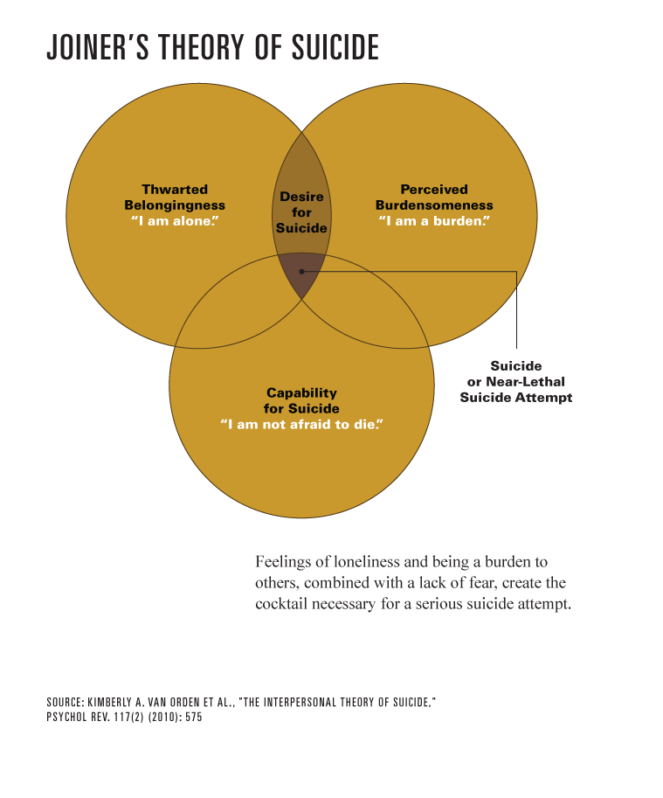
Information cited: “The Suicide Epidemic,” by Tony Dokoupil

The groundbreaking work by Dr. Thomas Joiner is comprised of three necessary and sufficient factors for suicide risk, and these can help identify strategies that will and won’t help:

- Thwarted Belongingness. We can always do something about this one by making a genuine connection with another person, and since all three factors are necessary for high risk of suicide, it may only be necessary to fix one. This is why it’s important to establish a good rapport with a person.

- Perceived Burdensomeness. We can prevent this from getting worse by avoiding solutions, advice, and judgments. We can sometimes improve it by reflecting back to the person things that we genuinely value or appreciate about them, but it has to be utterly sincere. If you can't find something specific, positive, and accurate to say, just move on to the next strategy. By building a strong rapport you may discover some genuine positives that you can reflect back to the person.

- Capability for Suicide. Desensitization to pain and death cannot be fixed in the short term; it’s acquired by life experience and extinguishes slowly, if ever.

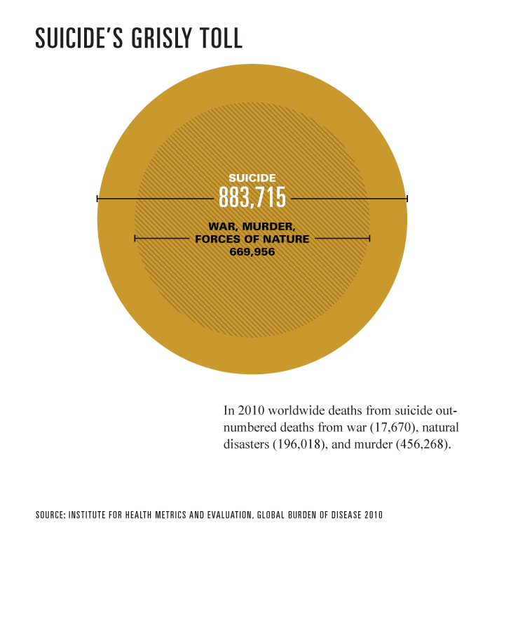
Information cited: “The Suicide Epidemic,” by Tony Dokoupil

Still Not Sure What to Say?
Here are some questions you could ask them that might help get you started. These examples can get you thinking about things to say and how to word the 'tough stuff'.

- It seems like that you haven't been acting like yourself lately. I'm worried about you, is something going on?

- What can I do to help?

- How can I help you?

- How long have you been feeling this way?

- Have you spoken with anyone else about all of this?

- Can I help you find someone to see about your concerns?

- Are you getting the care you need?

- It sounds like a part of you wants to live but there’s also a part of you that wants to die. I’m wondering if we could talk about how we can keep that living part safe from that part of you that wants to die?

- What do you feel like? What are you experiencing?

- Have you been having thoughts about trying to kill yourself?

- Have you ever had thoughts about hurting yourself?

- Do you think you might be in immediate danger?

LQR
Listen… Question… Respond

Warning signs of suicide:
Talking, reading, or writing about suicide or death
Talking about feeling worthless or helpless
Verbal cues: “I wish I were dead,” “I’m going to kill myself.”
Sudden change in behavior
Self-destructive behavior
Self-medication (abuse or drugs and/or alcohol)
Saying goodbye

If someone you care about exhibits these symptoms, use LQR!
Listen empathetically; let her/him know you are there for them.

Question: Ask her/him if (s)he is thinking about suicide. This lets them know it is safe to talk about their feelings.

Respond: Get the person to help as soon as possible. Never agree to keep suicide a secret. Tell the person’s family, friends, a counselor, or a doctor. Let them know who you would like to tell and why. Accompany the person to a doctor, counselor, or emergency room, or call the resources at the bottom of the page.

For more information, or to get help call:

Common Ground (800) 231-1127
National Suicide Prevention Lifeline (800) 273-8255

S.L.A.P.

S: Specificity of Plan
Does the person have a plan? Where? When? These questions help us to understand how long the person at risk has had thoughts of suicide and what the safety plan will be.

L: Lethality of Plan
It is always important to reduce access to lethal means, but it is especially critical if the plan involves quick and lethal means i.e. how they plan to die.

A: Accessibility to Means
If the person has a plan, do they have access to the means? Do they have a gun in their possession, collected pills or rope.

P: People available who can help
These are the people and or resources in the person’s life. Discussing this not only can help broaden the person at risk’s point of view, it helps you know who you can bring into the safety plan.

A SLAP Risk Assessment helps in different ways.
- Allowing the person at risk to discuss their plan builds rapport and trust.
- If an emergency intervention is needed (911) having the information from the SLAP risk assessment can be helpful to responders.
- It gives you solid information to share with the person’s caseworker, doctor, therapist, etc.
- Suicide is difficult to talk about. When you and the person at risk go to a support person, the facts acquired from the SLAP risk assessment help to jumpstart a tough conversation.

The Power of Three
At times our thoughts can become our own enemy, not always under our control and sometimes we need to let someone else in to help us figure it all out. This activity is meant to help prepare us for those times. Please take a moment, consider your own thoughts and feelings before filling these in.

After you’ve filled them in cut this paper out, fold it and keep it on you at all times in case of emergency. That emergency may look different for each person but with this sheet you know there are people, places and things you can turn to in your time of need.

3 people you trust that you can talk to for help
- __________________________________
- __________________________________
- __________________________________

3 things you can do to get out of a bad mood or situation
- __________________________________
__________________________________
- __________________________________
__________________________________
- __________________________________
__________________________________

3 professionals that you can that you can turn to for help
- __________________________________
- __________________________________
- __________________________________

